Search functionality within Mosaic
  - Service Transition document

Version | Author | Date | Comment
0.1 | Brendan Donnelly | 01/05/2020 | Initial draft
0.2 | Brendan Donnelly | 05/05/2020 | Updates following review with Janet McKnight and James Cox
0.3 | Brendan Donnelly | 18/05/2020 | Updates following review with Ruth Mason
0.4 | Brendan Donnelly | 19/05/2020 | Inclusion of files as part of the search results

Contents
1. Purpose 3
2. Glossary 3
3. Overview 3
4. Types of search 4
4.1 This site 4
4.2 Search collection 4
4.3 Section search 4
4.4 External search 5
5. Administration process 5
5.1 Search settings 5
5.2 Manage search scopes 6
5.2.1 Search collection 8
5.2.2 Section search 8
5.2.3 External search 9
5.3 Maintaining scope definitions 9
5.4 Scope association 10
5.5 Manage promotion items 11
5.5.1 Creating promotions 11
5.5.2 Updating promotions 11
6. Visitor UI 12

Purpose

This document provides detail to the changes made to the search functionality within Mosaic as part of the ‘UAS migration to Mosaic’ project. The document assumes no prior knowledge of existing search elements and covers the new items in as much detail as possible. The audience for this document is the users who carry out any form of site administration e.g. the Service Support team.

Glossary

Term | Definition
Search scope | Boundaries of a search e.g. within one collection, across multiple collections, etc.
Search collection | One or more sites grouped together to form the index for a set of search results (described more in this document)
Section search | A subset of a site which is marked for a specific search group e.g. all the Legislation content items on the Governance website
External search, External service | A search engine from another site e.g. searching on SOLO, which can be easily accessed by substituting the search criteria into a fixed URL

Overview

The new search functionality makes changes to the administration area of Mosaic and to the web front-end for each site.
On the administrative side, there will be greater flexibility over the types of search which a site owner could define and associate to their site. These different types are defined in the ‘Types of search’ section below. It will also be possible to create promoted search results by defining a set of keywords and associating these to a search item (for example, promoting relevant content in the run up to ‘Open days’).
In the web front-end, the changes will simplify the UI whilst enhancing the visitor’s interaction with the search results page. The search result items will be improved to contain more content and more information. For example, the search results will now contain files as well as web content – PDFs and the content of other document types will be indexed and made available for searching. There will also be the ability for a visitor to search within a sub-section of a site and to be taken to the search results of another site.

Types of search

This site

Every site will have a search definition created to include the content of the source site. This search scope will exist as standard and be set as the default search and so, for most sites, the interaction with the rest of the search administration items will be negligible.

Search collection

A search collection consists of all the searchable content belonging to one or more sites. A search collection is defined by a list of sites. This type of search is available to all sites and it is possible to add multiple search collections to a site. The process is detailed in the administration section below. The content of that collection then becomes all the searchable content within those sites.
A common search collection is all the UAS Mosaic sites. Another multi-site collection might consist of similar sites to a source site. For example, for IT Services a collection will exist for the IT Services site as well as IT Help and the Skills websites.

Section search

A section search allows a visitor to search within a subset of content items and files from a site. For example, this may be all items within ‘Legislation’ on the Governance website. The process to allow a section search on a site falls into three steps:

- Creating the Search taxonomy term(s)
  - A Service Request is made for a Search taxonomy
  - The Service team turn on the feature flag for this item
  - The administrator may define the term(s) when assigning to the content/file (as an open taxonomy) or the Service team may be able to assist with setting this up

- Assigning the term(s) to content and files within the site
  - The easiest method to assign Search taxonomy term(s) to a small set of content items is to open the content and add the term(s) (the search taxonomy field will be visible for content item or file once flagged on)
  - If an editor needs to add or remove a taxonomy term to many content items or files then the process is as follows:
    - Access the ‘Content’ or ‘Files’ tab in the ‘Manage content’ section of the site
    - There will be a button to ‘Edit search term mapping’
    - In the subsequent view, select the content items or files that need updating
    - From the ‘Operations’ picklist, choose one of the options for ‘Add search term’ or ‘Remove search term’ and click ‘Execute’
    - In the subsequent view, select a search taxonomy term to add or remove and click the add/remove button
    - When returned to the main Content/File mapping page, check that the changes have been made correctly
- Define and associate the section search for the site
  - This is defined in the administration process below

With those items set up, an editor can then place the ‘Section search’ widget on a page on their site and allow web visitors to search specifically within those content items set up with the search taxonomy.
Note that a separate function within the administration area will allow content items (including files) to be bulk-associated with the site’s search taxonomy terms.

External search

As the term suggests, an external search allows the site to be connected to an external search results page in order to allow the web visitor to run their search on a separate search engine. The web visitor submits their search on the Mosaic site and is then taken to the external search site to view the results. The URL for the search needs to be in a certain format for this type of search to work correctly (more details in the external search section below).
An example of the type of external search service can be seen on the Bodleian website when the visitor gets to run their search criteria on the SOLO website.

Administration process

Search settings

The first task for a Site Administrator is to set up a new search definition. In the Site Settings, select the Search tab.

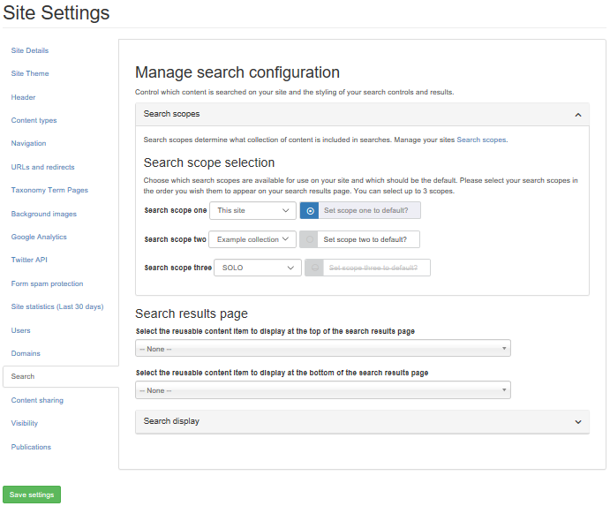
Figure 1 Area within Site Settings > Search tab

This Search area contains a set of panels allowing the administrator to perform different search-related functions.
The functions are:
- Manage search scopes
  - Entry point to a form showing the administrator the current scopes which they have defined on their site
  - Form also allows the administrator to add new scope items or edit/delete existing ones
- Scope association
  - Set of picklists allowing an administrator to choose up to three scopes for their site
  - Order of association is important
  - Default search can also be indicated at this point
- Manage promotion items
  - Entry point to a form allowing administrators to manage their list of promotion items
  - This section allows them to set up new items and remove old promotions

Manage search scopes

When looking to configure the search scopes for a website, the Site Administrator should select the link to ‘Search scopes’ from the panel in the Site Settings > Search tab.
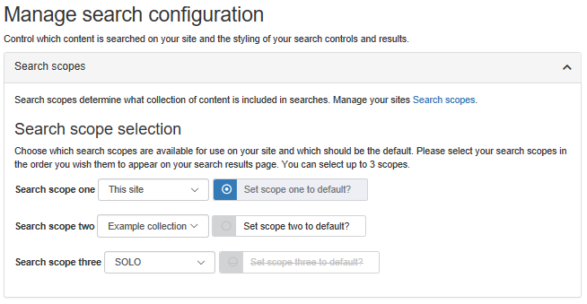
Figure 2 Search scope panel in the Search tab

This link presents the Site Administrator with a page showing a dropdown list of search types and a table providing an overview of the search scopes set up on their site.

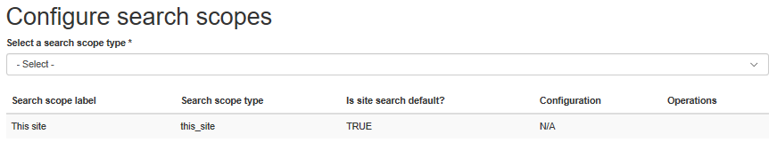
Figure 3 Initial view of search scope page

The dropdown list displays the types of search scope which can be set up. The choice in this picklist automatically creates a form for the Site Administrator to fill in. The details of each search scope selection are covered in each section below for Search collection, Section search, and External search.

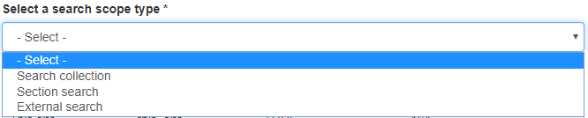
Figure 4 Select a search scope type picklist

When the Site Administrator has saved the details in the form, the definition appears in a table at the bottom of the page along with the other definitions which have been set up. Every site, by default, will have the ‘This site’ search collection set up (visible in figure 3 above).

Search collection

If the Site Administrator selects ‘Search collection’ in the dropdown, they are presented with a form allowing them to configure their collection. The form has two fields:

- Search results label
Standard entry textbox for the label to be used in the search results page to reference the search scope
- Site URLs
This is a large textbox allowing the Site Administrator to type or paste in a set of URLs. The URLs must be separated by a new line. Only when one or more sites are placed into the textbox will the ‘Look up sites’ button become active.

The process for creating a new search collection is as follows:
- Site Administrator types or pastes one or more URLs (one per line) into the ‘Site URLs’ textbox
- They clicks the ‘Look up sites’ button when it becomes active
  - This performs a look up on the Mosaic sites which are set to be visible to search engines
  - The output of this function is a list of URLs and site names
  - The output provides the Mosaic site name if the URL is valid
  - The output provide the value ‘No site found’ highlighted in red if the URL is invalid
- The Site Administrator can update the list of URLs, particularly if any items are invalid (note, the ‘Save’ button will only become active once the full list of sites has been validated)
- A value for the search results label can be put in and the scope definition saved

Note: the source site (“this site”) is automatically included in the search collection set of sites.

Section search

A section search allows a web visitor to search within a subset of content on a given site. It is assumed that this feature has been turned on for the site and that the Search taxonomy has been set up already. Content need not have been tagged at this point.
If a Site Administrator selects ‘Section search’ from the dropdown, the form they are presented with has two fields:

- Search results label
Standard entry textbox for the label to be used in the search results page to reference the search scope
- Search taxonomy term(s)
Taxonomy picklist allowing the selection of one or many terms from the list set up for the site

External search

An external search passes the web visitor from the Mosaic site through to the search results page of an external site. If the value for ‘External search’ is selected from the picklist then the Site Administrator can see a form with the following fields:

- Search results label
Standard entry textbox for the label to be used in the search results page to reference the search scope
- External URL field
Textbox for the Site Administrator to specify the external search URL. The URL needs to be in a format that allows the search string to be embedded.
For example, for Google, the search term can be embedded into the string
https://www.google.com/search?q=”$1”
by replacing the %1 by the search term. Similarly for SOLO, the string
http://solo.bodleian.ox.ac.uk/primo-explore/search?vid=SOLO&search_scope=LSCOP_ALL&query=any,contains,$1
So for a visitor using the search term ‘Euclid’, the above example would result in the URL:
http://solo.bodleian.ox.ac.uk/primo-explore/search?vid=SOLO&search_scope=LSCOP_ALL&query=any,contains,Euclid
This will search the SOLO catalogue for entries containing the term ‘Euclid’

Maintaining scope definitions

When a scope definition is created, it is added to the table beneath the picklist and form. The table provides the following detail about each scope:

Name | Description
Search scope label | Taken from the label field, this shows how the scope will be presented in the search results page
Search scope type | Indicates the type of search set up
Is site search default? | Options are TRUE or FALSE. Only one search can be TRUE (and one must be TRUE). This is set when associating the scopes to a site.
Configuration | For certain types, this will indicate how the search type has been set up. For example, for section searches this field will show the taxonomy term(s) selected.

For scope definitions (except for ‘This site’), it is possible to perform a number of operations on the item. The ‘Operations’ column shows the available tasks in the form of buttons for ‘Edit’ and ‘Delete’.
- Editing a scope definition
This brings the relevant information back into the appropriate form allowing the Site Administrator to update the details of the scope definition. For search collections, the validated list of URLs will be brought in to the form along with the search scope label. The ‘Look up sites’ button will be active but the ‘Save’ button will only become active once the list is validated.
- Deleting a scope definition
A standard Cancel/Delete operation page is presented to the Site Administrator to confirm scope deletion

Scope association

With a set of scope definitions created, it is now possible for the Site Administrators to associate them to the site. In Site Settings > Search, they are presented with a set of picklists from which they can select up to three scope definitions to bring on to their site. The order in which the definitions are selected is significant as this will determine, left to right, the order of the tabs in the search results page.
In this component, it is also possible to indicate the default search scope for the site. When a visitor runs a search from the header area of the site, the criteria will be applied to the default scope. They will be taken to the search results page with the default scope tab open. Note, it is not possible to choose an external search as the default scope.

Manage promotion items

A promoted search item is a specially-curated result which will appear for all visitors on a site who search for a specific set of keywords. The promoted items consist of all the attributes required to display the result to the visitor on the search results page. Each item can then be associated with multiple keywords or key-phrases. This means that an Editor could set up a search result and have it present when a visitor types ‘Open day’ or ‘University open days’, for example.
The promoted result will always appear in the top position on the search results page above the organic results.
The criteria used for the search will always be case insensitive i.e. searching for ‘Open day’ and ‘open day’ will produce the same result and only one of those criterion needs to be added as a key-phrase for the promoted item.

Creating promotions

In Site Settings > Search, there is a panel for ‘Managing promoted items’. Clicking on the link in this panel takes you through to the form to manage the promotion items.
On initial viewing, there will be no existing promoted items so the Editor will click the ‘Add’ button to begin the process. This will present them with a form with the following fields:

Field name | Description
Key phrase | This field holds the predicted search term which the Editor will type in the search header box. It is possible to add multiple key phrases for one promoted item (up to 10). The key phrases will be assessed case insensitively.
Title | This value will display as the title of the promoted item
Description | This value will display as the main body description text of the search item
Site name | This is the site name which will display for scopes using multiple sites in their collection
URL | This is the destination URL for the search item

Upon saving the promotion, the attributes will be displayed as they may appear in the search results page with the key-phrase(s) displayed alongside.

Updating promotions

When the editor views the promotion form after one or more promoted items have been created, along with the ‘Add’ button, they will see a read-only list of the items. The items will display as per the search results page along with the set of key-phrases associated with the item. There will also be buttons to edit and delete the promoted item. The edit button will open the form for the promoted item and allow changes to be made to the attributes. Deleting an item will remove it from the set of promotions.

Visitor UI

In the web front-end, the search header and the results page are the two areas seeing most change. A significant user journey change is the removal of the existing radio buttons on the search header. Whilst a very small UI update, it does remove the need for the visitor to decide where to run their search. Evidence coming from the user community indicated that, for many, the radio buttons were confusing and out-dated. This subtle change allows the site administrator to decide on the default search scope for the site and reduces the need for the visitor to make any decisions in the search process.
Another important change to the search results is the addition of files as well as web content. Files, such as .docs, PDFs, etc. will now be added to the site index and made available for searching.
The search results inherit the look and feel of the site. An example is shown here:

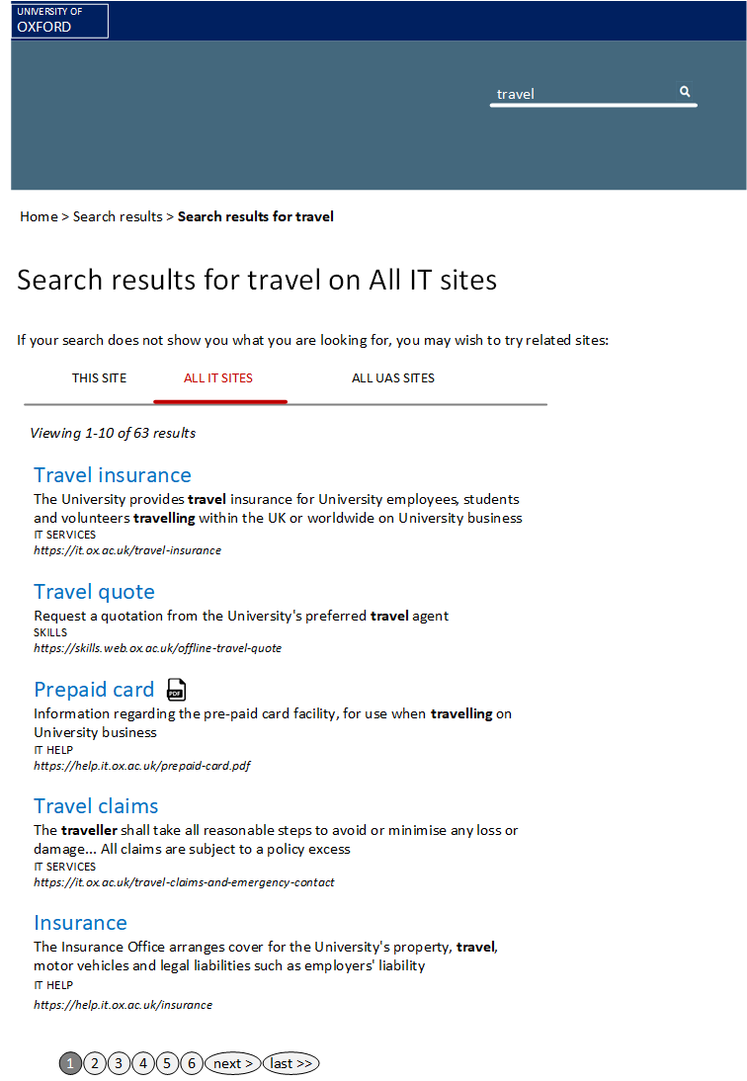
Figure 5 Mock-up of the search results page for a site with multiple scopes

The key elements of the page are as follows:
- Header search box
  - No radio buttons to control the scope of the search
  - Search term remains in place in the header box
- Breadcrumb
  - Appears where breadcrumbs are set in the Site Settings
- Search title
  - Replicates the search criteria used, as per current results page
  - If there are multiple scopes being used, the scope is also indicated
- Help text
  - This only appears if multiple scopes are in use
  - It reminds the visitor that they may wish to try the related sites
- Tab control
  - This is a new element for the search results page styled to be the same as the tab control used elsewhere on that site
  - Only visible if multiple scopes have been associated to the site
  - Clicking on a new tab, re-runs the search criteria in the scope definition for that tab
  - If the scope is for an external search then clicking on that tab brings the visitor to a new site’s search results page (with the criteria used in the source site)
- Number of results
  - Standard sign-posting for the visitor to show how many items are returned
- Search result items
  - An enhanced view of the results on the current page consisting of:
    - Clear title of the destination page
    - Body is formed of the destination page description. If that is not available then the sub-title is used. If that is not available then the text around the search term, found by the search engine, is used.
    - Site name, if the visitor is on a result set from a multi-site search collection
    - Finally the destination URL is specified
- Page navigation
  - Standard multi-page navigation

